**Lab 2 – Implementing Algorithms**



1. Implement the tree-drawing algorithm (derived in Friday’s class and described in the following images) in C.

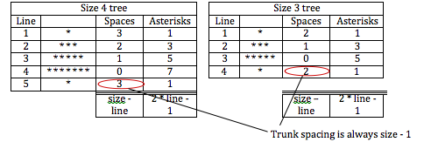

1. Using the Scratch project provided (**RockPaperScissors(start of).sb**), implement your algorithm (derived in Friday’s class) in Scratch.
2. Play the following game – *Towers of Hanoi*:

<http://www.mathsisfun.com/games/towerofhanoi.html>

1. **Week 3 Quiz** will open at 11.45 and close at 12.00. This will go towards your overall CA mark.